

**ANL252**

**Python for Data Analytics**

**Group-based Assignment**

**January 2023 Presentation**

**Submitted by:**

|  |  |
| --- | --- |
| **Name** | **PI No.** |
| CHEN YAOGUANGHUA | E2270438 |
| CHIA WAN QI, FELICIA | Z2210118 |
| JAZLYN J BINTE ABDULLAH | Z1882515 |
| RAYNER FOO SHI HAN | E2211650 |

**Tutorial Group: T05**

**Instructor’s Name: Mr. Kumar Munish**

**Submission Date: 19 February 2023**

**Declaration Page**

We, members of group 2 , do hereby declare that we each contributed to this assignment and that we collectively agree to a shared grade.

|  |  |  |
| --- | --- | --- |
| Name | Contribution | Signature |
| RAYNER FOO SHI HAN (Team Lead) | I did questions 1A, 1B and 1C |  |
| CHEN YAOGUANGHUA | I did questions 1A, 1B and 1C |  |
| CHIA WAN QI, FELICIA | I did questions 1A, 1B and 1C |  |
| JAZLYN J BINTE ABDULLAH | I did questions 1A, 1B and 1C |  |

Group-based Assignment

**Question 1A)**

# Proportion of Males and Females in each Business Unit

|  |  |  |  |
| --- | --- | --- | --- |
| **Count of Gender** | **Column Labels** |  |  |
| **Row Labels** | **Business Development** | **HR Product Development** | **Grand Total** |
| Female | 159 | 17 327 | 503 |
| Male | 218 | 34 495 | 747 |
| **Grand Total** | **377** | **51 822** | **1250** |

## Figure 1.1 Pivot table of the proportion of Males and Females in each Business Unit

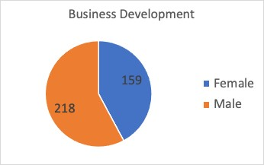

Figure 1.2 Pie chart of the proportion of Males and Females in the Business Development Unit.

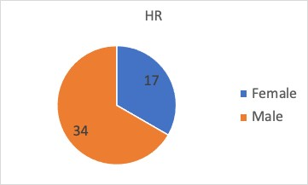

Figure 1.3 Pie chart of the proportion of Males and Females in the HR Unit.

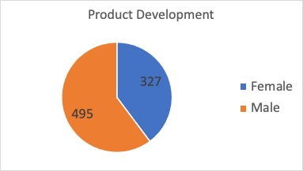

Figure 1.4 Pie chart of the proportion of Males and Females in the Product Development Unit.

# Insights and observations

1. The business development division employs 218 males, which is a higher proportion of males than females which is at 159.
2. The HR division employs 34 males, which is a higher proportion of males than females which is at 17.
3. The product development division employs 495 males, which is a higher proportion of males than females which is at 327
4. The HR division has a relatively low percentage of female employees compared to the other divisions may suggest that there is a need to improve efforts to attract and retain female employees in this division to provide for better diversity and inclusion.
5. The business development division has a higher percentage of female employees compared to other division may suggest that this division has a greater emphasis on attracting and retaining female talent.
6. The percentage of males in the company is greater than that of the females at 60% to 40%.

These observations can be utilized to pinpoint areas where the business may need to take action to rectify any staff imbalances or inequities. Such as the percentages of males and females in each division can reveal potential biases in recruitment, selection as well as promotion processes.

For instance, if a particular division has a disproportionately high percentage of one gender, it may indicate that the recruitment or selection process for that division is biased in favour of that gender.

By analysing the percentage of males and females in each division and identifying any disparities and biases, the company can take steps to improve its diversity and inclusion efforts and create a more equitable and inclusive workplace.

For instance, if a corporation wishes to boost the proportion of women working in the business development division, they can execute targeted recruitment or retention initiatives.

Similar to this, the business can investigate the causes of the lower proportion of women working in the product development division and take action to remove any obstacles or hurdles that might be limiting women from entering or succeeding in that industry.

Similarly, if there is a significant gender disparity in the higher job grades or roles within a particular unit, it may suggest that the promotion process within that unit is biased against one gender.

|  |  |  |  |  |  |
| --- | --- | --- | --- | --- | --- |
| **Count of SatisfactionRoleColumn Labels**  **Row Labels 1 2** | | | **3** | **4** | **Grand Total** |
| Account Executive | 11 | 16 | 25 | 20 | 72 |
| Account Manager | 63 | 42 | 81 | 90 | 276 |
| HR | 10 | 14 | 9 | 9 | 42 |
| Manufacturing Head | 23 | 27 | 45 | 37 | 132 |
| Product Executive | 22 | 19 | 38 | 38 | 117 |
| Product Head | 12 | 14 | 25 | 18 | 69 |
| Product Research | 44 | 49 | 72 | 81 | 246 |
| Section Manager | 16 | 17 | 20 | 28 | 81 |
| Technical Support | 46 | 44 | 61 | 64 | 215 |
| **Grand Total 247** | | **2423763851250** | | | |

## Figure 1.5

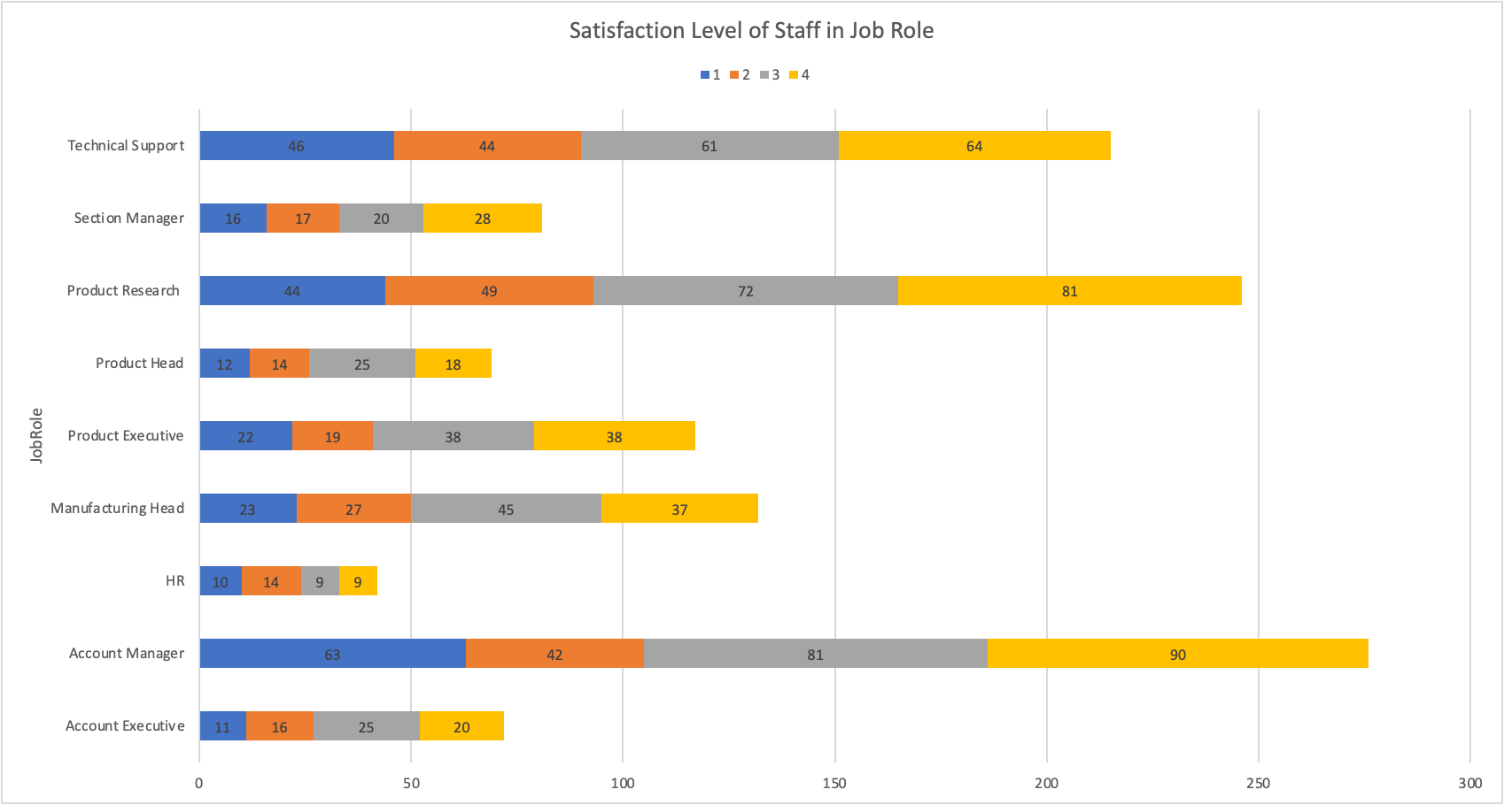

# Figure 1.6 Insights and observations

Satisfaction of a role, is the level of contentment a staff feels for their job.

In which, it would be more than just their satisfaction on daily duties at work but also with their colleagues and superior. As well as their satisfaction with the company's policies which would affect their job and personal lives. Staff satisfaction level in a job role, would let one to understand the satisfaction of employees for their performance and quality of work and relationships with co-workers.

From the stacked bar graph, we are able to see the number of staff who have selected their satisfaction level in their job role. For example, the number of staff who chose 1 as their satisfaction role in Section Manager. We are also able to tell the number of staff in each individual job role.

|  |  |  |  |
| --- | --- | --- | --- |
| **Average of MonthlyPay** | **Column Labels** |  |  |
| **Row Labels** | **Female** | **Male** | **Grand Total** |
| **0 - 10 Years** | **$4,472** | **$4,434** | **$4,448** |
| **11 - 15 Years** | **$6,627** | **$6,359** | **$6,474** |
| **16 - 20 Years** | **$6,709** | **$7,020** | **$6,890** |
| **21 + Years** | **$14,930** | **$16,016** | **$15,537** |
| **Grand Total** | **$6,646** | **$6,483** | **$6,548** |
| **Average of MonthlyPay** | **Column Labels** |  |  |

## Figure 1.6

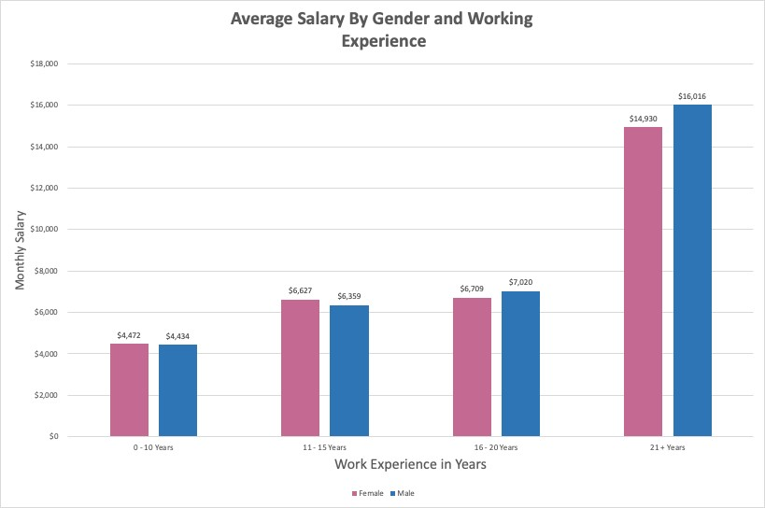

# Figure 1.7 Insights and observations

1. Throughout all levels of working experience, men employees make slightly more money on average than female employees.
2. For both male and female employees, the average monthly pay rises as working experience does. But, as working experience grows, the wage disparity between men and women worsens.
3. Employees with 21+ years of working experience show the biggest gender pay gap, with male employees making an average of $16,016 compared to female employees making an average of $14,930.
4. It's interesting to note that employees with 0–10 years of work experience make more money on average per month than those with 11–15 years. This might be the result of a number of things, like shifting pay scales over time or recent recruiting for roles with greater salaries.

The gender wage discrepancy inside the organization is generally highlighted by this pivot table, especially as Working Experience grows. It also demonstrates how crucial it is to take into account working experience when examining average monthly compensation because the length of an employee's tenure at the company has a big impact on their income. The business may want to look at strategies to close the gender pay gap, like carrying out a pay equity analysis or putting in place policies to support diversity and inclusion.

# Relationship Between Performance Ratings & Salary Increments

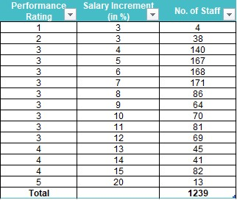

## Figure 1.8

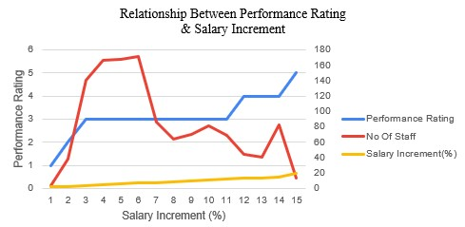

Figure 1.9

# Insights and Observations

1. The relationship between performance ratings and salary increment are mostly positively correlated.
2. Even with the same performance ratings, staff receive different percentages in salary increments. This is evident with staff rated 3 and 4.
3. The most number of staff receive a 7% increase in salary increment and the least number of staff receive a 3% increase in salary increment.
4. The lowest performance rated (1) staff received a 3% increase while the highest performance rated (5) staff received a 20% increase. This is a 17% difference in their salary increment based on their performance.
5. Out of 1239 staff, the majority received a “3” for their performance ratings.

The business may need to be transparent if there are any additional factors that go into the justification of staff performance ratings and salary increments. It is clear from the line chart that the salary increments are not solely based on performance ratings.

The salary increment for staff that were rated a “3” ranges from 3% to 11%. That is an 8% difference, even though they all receive the same ratings. The same goes for those rated “4” as they range between 13% to 15% which is a 2% difference. Knowing others performing the same yet receiving a higher or lower pay increment may affect staff morale. It can be seen as unjust. If there are additional factors, the business will need to be more transparent with their staff regarding those factors.

With the mostly positive correlation of higher performance rating equal to higher salary increments, this may encourage staff to perform better as it is a good incentive.

Aside from only rewarding those that received a high rating, more positive encouragement should be implemented for those that are performing badly. The business should look into what can be done to motivate those who receive a 1 or 2 to improve their work performance.

**Question 1B)**

# Python generated charts and tables for the proportion of Males and Females in each Business Unit

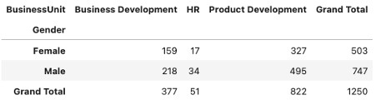

Figure 2.1 python generated table of the proportion of Males and Females in each Business Unit.

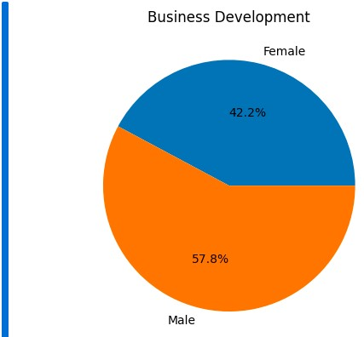

## Figure 2.2 python generated pie chart of the proportion of Males and Females in the Business Development Unit

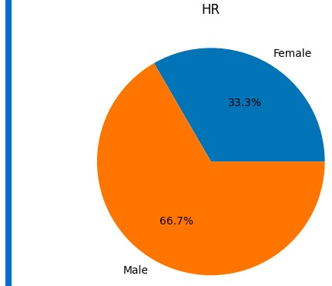

## Figure 2.3 python generated pie chart of the proportion of Males and Females in the HR Business Unit

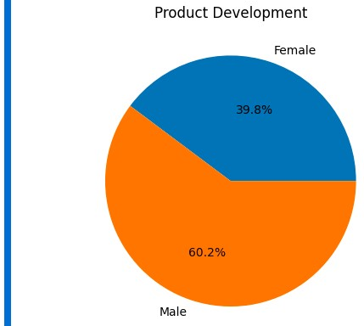

## Figure 2.4 python generated pie chart of the proportion of Males and Females in the Product Development Unit

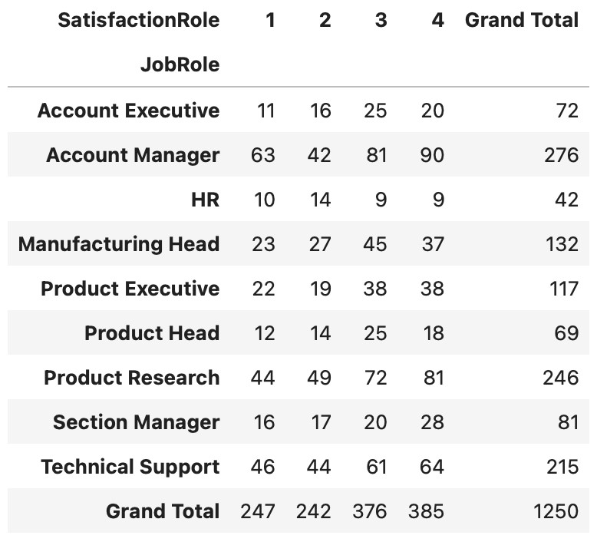

## Figure 2.5

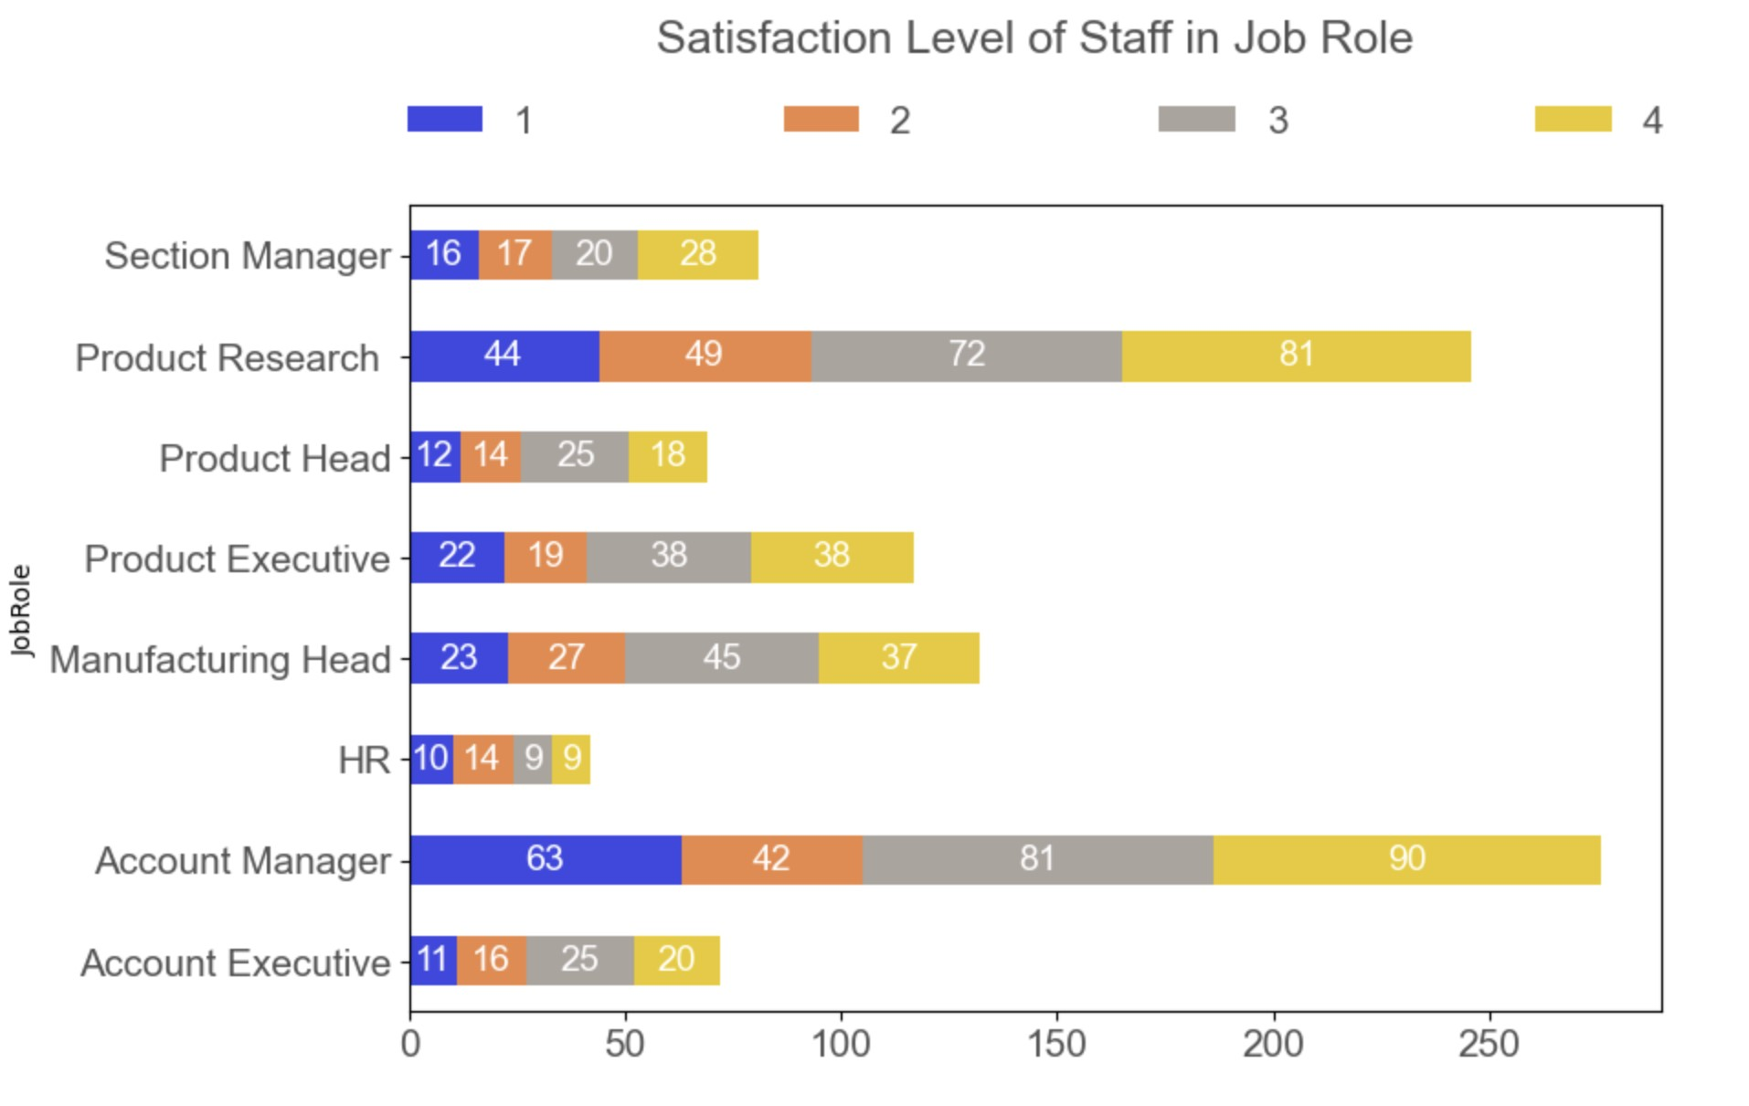

# Figure 2.6 Python generated line chart and table for the Relationship Between Performance Rating & Salary Increment

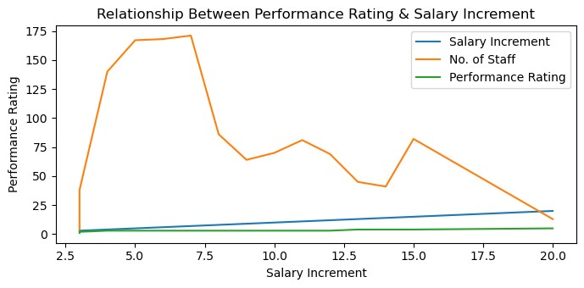

## Figure 2.7 Python Generated Line Chart

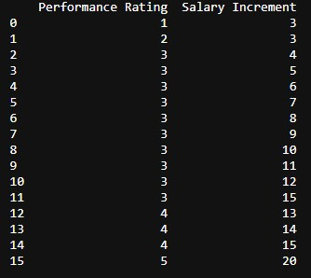

Figure 2.8 Python Generated Table

# Python generated line chart and table for the Relationship Between Performance Rating & Salary Increment

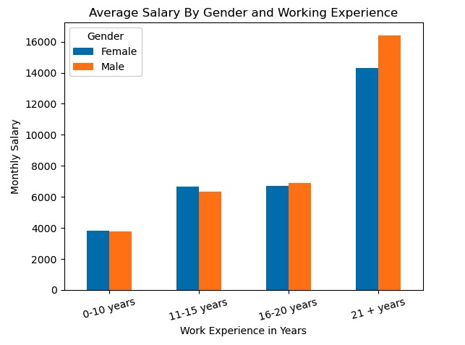

## Figure 2.9

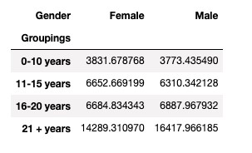

## Figure 2.10

**Question 1C)**

1. Current staff strength output

|  |
| --- |
| Please select an option:   1. Display Current Staff Strength 2. Display Current Staff Annual Remuneration 3. Display Eligible Long Service Award Recipients 4. Exit   Enter option number: 1  Current Staff Strength: 1057  Breakdown by business unit and gender:  BusinessUnit Gender Count   1. Business Development Female 129 2. Business Development Male 170 3. HR Female 12 4. HR Male 30 5. Product Development Female 293 6. Product Development Male 423   Would you like to return to main menu? (Indicate yes or no): no  Exiting program  Process finished with exit code 0 |

1. Current staff annual remuneration output

Please select an option:

1. Display Current Staff Strength
2. Display Current Staff Annual Remuneration
3. Display Eligible Long Service Award Recipients
4. Exit

Enter option number: 2

Current total annual remuneration: $87182508

Current median monthly salary: $5238.0

Would you like to return to main menu? (Indicate yes or no): no

Exiting program

Process finished with exit code 0

1. Eligible long service award recipients output

|  |
| --- |
| Please select an option:   1. Display Current Staff Strength 2. Display Current Staff Annual Remuneration 3. Display Eligible Long Service Award Recipients 4. Exit   Enter option number: 3  EmpID JobRole Age  688 1688 Account Manager 60  1193 2193 Product Executive 60  918 1918 Account Manager 60  1032 2032 Section Manager 60 936 1936 Account Manager 60  ... ... ... ...  394 1394 Product Research 35  1184 2184 Technical Support 35 1187 2187 Product Research 35  1172 2172 Manufacturing Head 35  561 1561 Product Executive 35  [694 rows x 3 columns]  Would you like to return to main menu? (Indicate yes or no): no  Exiting program  Process finished with exit code 0 |

1. Exit output

Please select an option:

1. Display Current Staff Strength
2. Display Current Staff Annual Remuneration
3. Display Eligible Long Service Award Recipients
4. Exit

Enter option number: 4

Exiting program

Process finished with exit code 0

**APPENDIXES**

**APPENDIX 1 – DATA DICTIONARY**

|  |  |  |
| --- | --- | --- |
| EmpID | Employee identifier | |
| BusinessUnit | Business Unit / Depatrment | |
| Education | Education level  (1: Others, 2: High School, 3: Tertiary, 4: Postgraduate) | |
| FieldOfStudy | Field of academic study | |
| Gender | Gender | |
| Age | Age in years | |
| ProximityToHome | Distance between home and work location in km | |
| Travel | Frequency of work travel | |
| JobGrade | Job grade (1-5, where 5 is highest) | |
| JobRole | Job Role | |
| MaritalStatus | Marital Status | |
| MonthlyPay | Monthly pay | |
| PreviousEmployers | Number of previous employers worked for | |
| SalaryIncrement | Last salary increment in percentage | |
| PerformanceRating | Last appraisal performance rating (1-5, where 5 is highest) | |
| WorkingExperience | Number of years of working experience | |
| TrainingAttended | Number of trainings attended in the previous year | |
| WorkLifeBalance | Employee rating of work life balance (1-4, where 4 is highest) | |
| WithCompany | Number of years working for the organization | |
| CurrentRole | Number of years working in the current role | |
| LastPromoted | Number of years since last promotion | |
| CurrentManager | Number of years reporting to the current manager | |
| SatisfactionCompany | Satisfaction rating with respect to the company (1-4, where 4 is highest) | |
| SatisfactionRole | Satisfaction rating with respect to the job role (1-4, where 4 is highest) | |
| SatisfactionCoworkers | Satisfaction rating with respect to fellow co-workers (1-4, where 4 is highest) | |
| LeftCompany | Whether the employee has left the company | |
| import pandas as pd  # Read CSV into pandas data = pd.read_csv('GBA.csv')  # Create a pivot table with Gender as the rows and BusinessUnit as the columns,  # and counting the number of employees in each group gender_count = pd.pivot_table(data,  values='EmpID', index=['Gender'], columns=['BusinessUnit'], aggfunc='count', margins=True,  margins_name='Grand Total'  )  # print the pivot table gender_count.iloc[:, 0:4] | |

*Appendix 2.1 to figure 2.1*

|  |
| --- |
| import pandas as pd import matplotlib.pyplot as plt  # Read CSV into pandas data = pd.read_csv('GBA.csv')  # Create a pivot table with Gender as the rows and BusinessUnit as the columns,  # and counting the number of employees in each group gender_count = pd.pivot_table(data,  values='EmpID', index=['Gender'], columns=['BusinessUnit'], aggfunc='count', margins=True,  margins_name='Grand Total'  )  # Define the data for the Business Development Unit pie chart bd_data = gender_count.loc['Female':'Male', 'Business Development']  # Define the labels for each of the pie chart labels = ['Female', 'Male']  # Create the Business Development Unit pie chart plt.pie(bd_data, labels=labels, autopct='%1.1f%%') plt.title('Business Development') plt.show() |

*Appendix 2.2 to figure 2.2*

|  |
| --- |
| import pandas as pd import matplotlib.pyplot as plt  # Read CSV into pandas data = pd.read_csv('GBA.csv')  # Create a pivot table with Gender as the rows and BusinessUnit as the columns,  # counting the number of employees in each group gender_count = pd.pivot_table(data, values='EmpID', index=['Gender'], columns=['BusinessUnit'], aggfunc='count', margins=True, margins_name='Grand Total'  )  # Define the data for the HR Unit pie chart hr_data = gender_count.loc['Female':'Male', 'HR']  # Define the labels for each of the pie chart labels = ['Female', 'Male']  # Create the HR Unit pie chart hr_count = gender_count.loc['Female':'Male', 'HR'] hr_count.plot(kind='pie', title='HR', autopct='%1.0f%%') plt.ylabel('') plt.show() |

*Appendix 2.3 to figure 2.3*

|  |
| --- |
| import pandas as pd import matplotlib.pyplot as plt  # Load the data from the CSV file into a Pandas DataFrame data = pd.read_csv('GBA.csv')  # Create a pivot table with Gender as the rows and BusinessUnit as the columns,  # counting the number of employees in each group gender_count = pd.pivot_table(data, values='EmpID', index=['Gender'], columns=['BusinessUnit'], aggfunc='count', margins=True, margins_name='Grand Total'  )  # Define the data for the Product Development Unit pie chart pd_data = gender_count.loc['Female':'Male', 'Product Development']  # Define the labels for each of the pie chart labels = ['Female', 'Male']  # Create the Product Development Unit pie chart pd_count = gender_count.loc['Female':'Male', 'Product Development'] pd_count.plot(kind='pie', title='Product Development', autopct='%1.0f%%') plt.ylabel('') plt.show() |

*Appendix 2.4 to figure 2.4*

|  |
| --- |
| ## How to plot a stacked bar graph to know the satisfaction level of the staff in their job role  import pandas as pd import matplotlib.pyplot as plt  ## Read CSV into pandas df = pd.read_csv("/Users/feliciachia/Desktop/ANL252 - Python For Data Analytics/GBA.csv")  ## To sort the data into a pivot table in Qn 1 (a), so that it would be easier to plot the stacked bar graph table1 = df.assign(val=1).pivot_table(columns = 'SatisfactionRole', index = 'JobRole', values =  'val', aggfunc = 'count', margins=True, margins_name='Grand Total') table1 |

### Appendix 2.5 to figure 2.5

|  |
| --- |
| ## How to plot a stacked bar graph to know the satisfaction level of the staff in their job role  import pandas as pd import matplotlib.pyplot as plt  ## Read CSV into pandas df = pd.read_csv("/Users/feliciachia/Desktop/ANL252 - Python For Data Analytics/GBA.csv")  ## To sort the data into a pivot table in Qn 1 (a), so that it would be easier to plot the stacked bar graph table1 = df.assign(val=1).pivot_table(columns = 'SatisfactionRole', index = 'JobRole', values = 'val', aggfunc = 'count', margins=True, margins_name='Grand Total')  table1  ## To select the font colors font_color = '#525252' csfont = {'fontname':'Arial'} # title font hfont = {'fontname':'Arial'} # main font  colors = ['#3d48e3', '#ed8747', '#aba49f', '#ebc81a']  ## To plot the stacked bar graph  ax = table1.iloc[0:8, 0:4].plot.barh(align='center', stacked=True, figsize=(10, 6), color=colors) plt.tight_layout()  title = plt.title('Satisfaction Level of Staff in Job Role', pad=60, fontsize=18, color=font_color, **csfont) title.set_position([.5, 1.02])  for label in (ax.get_xticklabels() + ax.get_yticklabels()):  label.set_fontsize(15) plt.xticks(color=font_color, **hfont) plt.yticks(color=font_color, **hfont)  legend = plt.legend(loc='center', frameon=False, bbox_to_anchor=(0., 1.02, 1., .102), mode='expand', ncol=4, borderaxespad=-.46, ## remove padding prop={'size': 15, 'family':'Arial'})  for text in legend.get_texts(): plt.setp(text, color=font_color) ## Legend font color  ## Annotations for p in ax.patches: width, height = p.get_width(), p.get_height() x, y = p.get_xy() ax.text(x+width/2, y+height/2,  '{:.0f}'.format(width), horizontalalignment='center', verticalalignment='center', color='white', fontsize=14,  **hfont)  plt.subplots_adjust(top=0.8, left=0.26) |

### Appendix 2.6 to figure 2.6

|  |
| --- |
| import pandas as pd import matplotlib.pyplot as plt  # Read data from CSV file df = pd.read_csv('ANL252DATA.csv')  # Get x-axis data x = df['Salary Increment']  # Get y-axis data for three data sets y1 = df['Salary Increment'] y2 = df['No. of Staff'] y3 = df['Performance Rating']  # Creating a new plot fig, ax = plt.subplots()  # Plot lines ax.plot(x, y1, label='Salary Increment') ax.plot(x, y2, label='No. of Staff') ax.plot(x, y3, label='Performance Rating')  # Set axis labels and title ax.set_xlabel('Salary Increment') ax.set_ylabel('Performance Rating') ax.set_title('Relationship Between Performance Rating & Salary Increment')  # Add legend ax.legend()  # Display the line chart plt.show() |

### Appendix 2.7 to figure 2.7

|  |
| --- |
| import pandas as pd  # Read CSV file df = pd.read_csv('ANL252GBA.csv')  # Extract "PerformanceRating" and "SalaryIncrement" columns data = df.loc[:, ['PerformanceRating', 'SalaryIncrement']]  # Group by "PerformanceRating" and "SalaryIncrement" and compute the mean data = data.groupby(['PerformanceRating', 'SalaryIncrement']).mean().reset_index()  # Setting column names data.columns = ['Performance Rating', 'Salary Increment']  # Generate table print(data) |

### Appendix 2.8 to figure 2.8

|  |
| --- |
| import numpy as np import pandas as pd import matplotlib.pyplot as plt  # Read CSV file  df = pd.read_csv("GBA.csv")  # Use pivot table method to generate and compare Working Experience vs Gender with Monthly Pay as values test1 = df.pivot_table( index = ["WorkingExperience"], columns = "Gender", values = "MonthlyPay", margins_name = "Grand Total", margins = False  )  # Reset index  test1.reset_index(inplace = True)  # Set Index with comparision Working Experience test1.set_index('WorkingExperience', inplace = True)  # Reset index  test1.reset_index(inplace=True)  # Grouping range of years using for loop years_group = []  for years in test1['WorkingExperience']: |

|  |
| --- |
| if years < 11:  group = ['0-10 years']  elif years >= 11 and years < 16: group = ['11-15 years']  elif years >= 16 and years < 21:  group = ['16-20 years']  else:  group = ['21 + years']  years_group += group  groupings = np.array(years_group)  test1.set_index(groupings,inplace = True)  # Insert new column name as Groupings test1.insert(0, 'Groupings', groupings)  # Delete working experience column which is not needed newdf = test1.drop("WorkingExperience", axis='columns')  # Use Group By Method to group range years together  newdf2 = newdf.groupby("Groupings")[["Female","Male"]].agg('mean')  # Plot Bar Chart newdf2.plot.bar( xlabel="Work Experience in Years", ylabel="Monthly Salary",  rot=15, title="Average Salary By Gender and Working Experience"  ) |

# Display results display(newdf2)

### Appendix 2.9 to figure 2.9 & figure 2.10

|  |
| --- |
| import pandas as pd main_menu = 'yes'  # Read CSV into pandas df_staff_data = pd.read_csv("GBA.csv")  # Define a function to display the current staff strength and breakdown of staff strength by BU and Gender def current_staff_strength():  # Using specific column name and string to identify employees that are still in the company to get current strength column_name = 'LeftCompany' search_string = 'No'  # Count the number of times the string 'No' appears in the column 'LeftCompany' count_no = (df_staff_data['LeftCompany'] == search_string).sum() print('Current Staff Strength: ' f'{count_no}')  # Breakdown of staff strength by Business Unit and Gender staff_breakdown = df_staff_data.groupby(['BusinessUnit', 'Gender'])[column_name].apply( lambda x: (x == search_string).sum()).reset_index(name='Count')  print("Breakdown by business unit and gender:") print(staff_breakdown)  # Define a function to display the current staff total annual remuneration and current staff median monthly salary def current_staff_annual_remuneration(): # Filter for staff that are still in the company filtered_staff_data = df_staff_data.query("LeftCompany == 'No'")  # To calculate current total annual remuneration  median_monthlypay = filtered_staff_data['MonthlyPay'] * 12 current_total_annual_remuneration = median_monthlypay.sum() print("Current total annual remuneration: " + "$" f'{current_total_annual_remuneration}')  # To show current median monthly salary  median_monthlypay = filtered_staff_data['MonthlyPay'] print("Current median monthly salary: " + "$" f'{median_monthlypay.median()}')  # Define a function to display eligible long service award recipients def eligible_long_service_award_recipients(): # Filter for staff that are still in the company df_staff_data.query("LeftCompany == 'No'")  # Sort data by descending age filtered_staff_data = df_staff_data.sort_values("Age", ascending=False)  # Filter for staff that are 35 and older staff_above_35 = filtered_staff_data.query("Age >= 35") long_service_award_checker = staff_above_35[['EmpID', 'JobRole', 'Age']] print(long_service_award_checker)  # Define a function which will check option selected def execute_option(option):  if option == 1:  # To show current staff strength current_staff_strength()  elif option == 2:  # To show current staff annual remuneration current_staff_annual_remuneration()  elif option == 3:  # To show eligible long service award recipients eligible_long_service_award_recipients()  elif option == 4:  # Exit the program after informing user program is exiting print("Exiting program") exit() else: |
| # Any incorrect input will prompt user to provide input again print("Invalid option. Please enter a number between 1 and 4.")  # To provide an option to loop back to main menu when options 1/2/3 has been selected while main_menu == 'yes':  # Prompt the user to select an option while True:  # Display available options to the user print("Please select an option:") print("1. Display Current Staff Strength") print("2. Display Current Staff Annual Remuneration") print("3. Display Eligible Long Service Award Recipients") print("4. Exit")  # Prompts user to input an option option = input("Enter option number: ")  # To check that the input option is a numeric value between 1 and 4 if option.isnumeric() and int(option) in range(1, 5):  option = int(option) execute_option(option) break  # Invalid input will prompt user to try again with the valid options else:  print("Invalid option. Please enter a number between 1 and 4.")  while True:  # Prompts the user whether they would like to return to main menu main_menu = str(input('Would you like to return to main menu? (Indicate yes or no): ')).lower() if main_menu == 'yes' or main_menu == 'no':  print('Exiting program') break  # Invalid input will prompt user to try again until valid option is selected else:  print('Invalid Input') |

## Appendix for output in question 1C **Referencs**

Kuznetsova, J. (n.d.). *jukuznets/jupyter-notebooks*. Retrieved February 16, 2023, from Github:

<https://github.com/jukuznets/jupyter-notebooks/blob/main/mpl-stacked.ipynb>